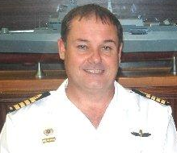
BIOGRAPHY  CAPTAIN (SA NAVY) J.E. SINOVICH | 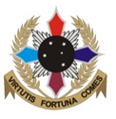  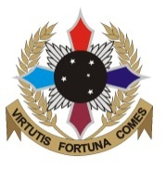
Captain Sinovich is a Combat Officer in the South African Navy, presently serving as SSO Maritime Capability at the Joint Operations Division.

On joining the SA Navy in January 1983 Capt Sinovich was selected for officers training at the Naval College in Gordon’s Bay. After graduating from Naval College and having successfully completed the Combat Officer Qualifying course, he was appointed to the Frigate, SAS PRESIDENT PRETORIUS, as an officer under training.

During the next four years he alternated between appointments at sea and attending various qualifying courses ashore. In 1993 he was appointed as the Personnel Development Officer of the Mine Warfare Base including all the MCM vessels. He was also responsible for the operational test and evaluation of the 22 meter Air Sea Rescue Launches during this period.

In 1994 Capt Sinovich was appointed as the Operations Officer of the Combat Support Ship SAS DRAKENSBERG. During this one-year appointment the ship visited nine countries in Africa and Europe, participating in many combined exercises with foreign navies.

Capt Sinovich assumed command of the Minesweeper SAS WALVISBAAI on 3 Feb 95. In Feb 96 he was appointed in command of the Minehunter SAS UMHLOTI.

On completion of his command term, Capt Sinovich was appointed to the Maritime Warfare School as the Training Officer responsible for the Functional Training of Combat Officers. On graduating from the Naval Command and Staff Course, which he attended from Jan 99 to Dec 99, he was re-appointed to the Naval Staff College as the Senior Directing Staff Officer, for Junior Staff and Warfare Courses.

In 2000 the South African National Defence Force initiated Project PROFUSION to establish a Joint Senior Command and Staff Programme to replace the existing Service courses. Capt Sinovich was appointed as a project officer for Project PROFUSION in Mar 2001.

In April 2002 Capt Sinovich was selected to attend the Naval Command Course (NCC) at the United States Naval War College in Newport, Rhode Island. He graduated from the NCC on 20 June 2003, achieving a Diploma in National Security, Strategy and Policy and Joint Military Operations.

From July 2003 to Dec 2005 Capt Sinovich served as SDS Joint Warfare at the SA National War College. During this appointment Capt Sinovich attended a Joint Operational Planning course presented by the UK armed forces in South Africa.

In Jan 2005 Capt Sinovich was selected to represent the SANDF as a Defence Attaché. On successful completion of the Defence Attaché course he was appointed as the DA to Germany and the Czech Republic from May 2006 to July 2009.

On returning from his appointment as DA, Capt Sinovich was appointed as the SSO Capability Development at the Joint Operations Division. He successfully completed the ENSP 23/11 in July 2011.

